T CODE - SMARTFORMS

CREATE A SMARTFORM

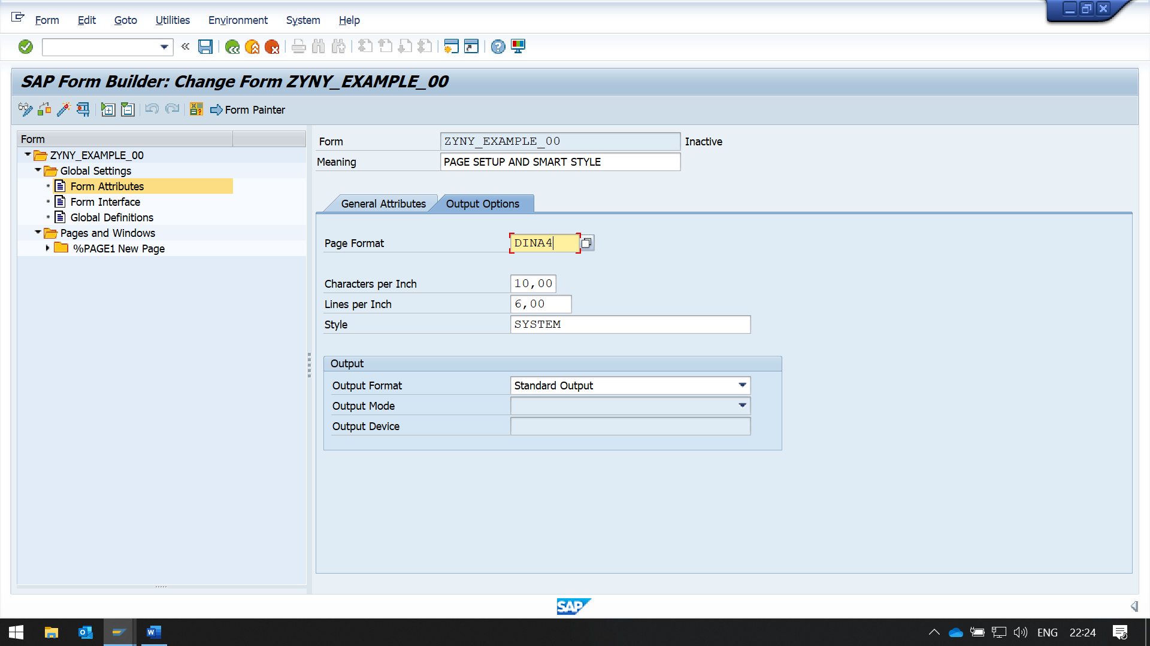IN PAGE FORMAT, CHOOSE DINA4 FOR A4 PAPER FORMAT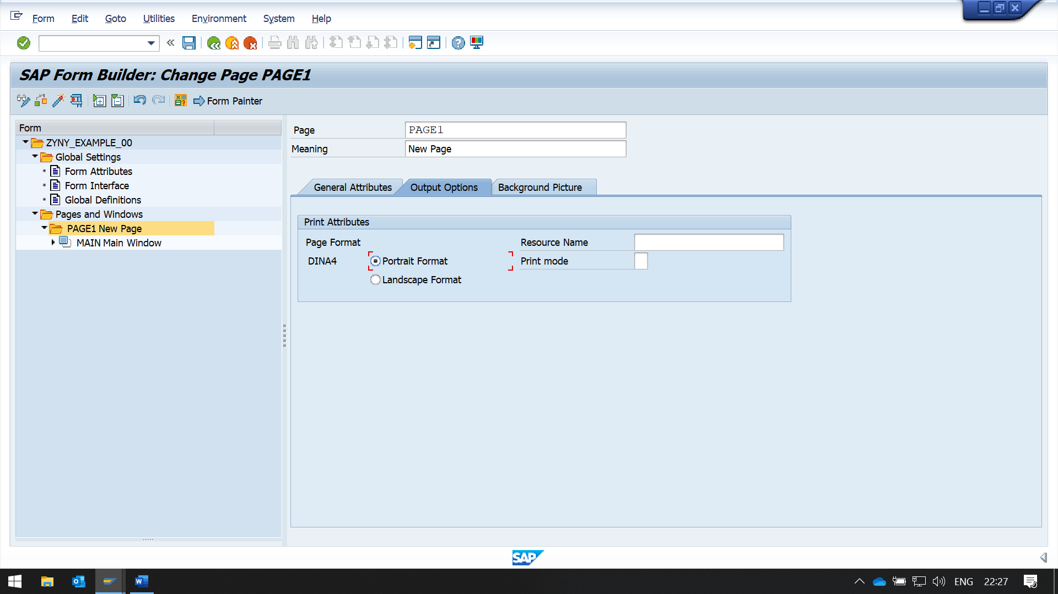

IN NEW PAGE -> OUTPUT OPTION

WE CAN CHOOSE PORTRAIT OR LANDSCAPE MODE

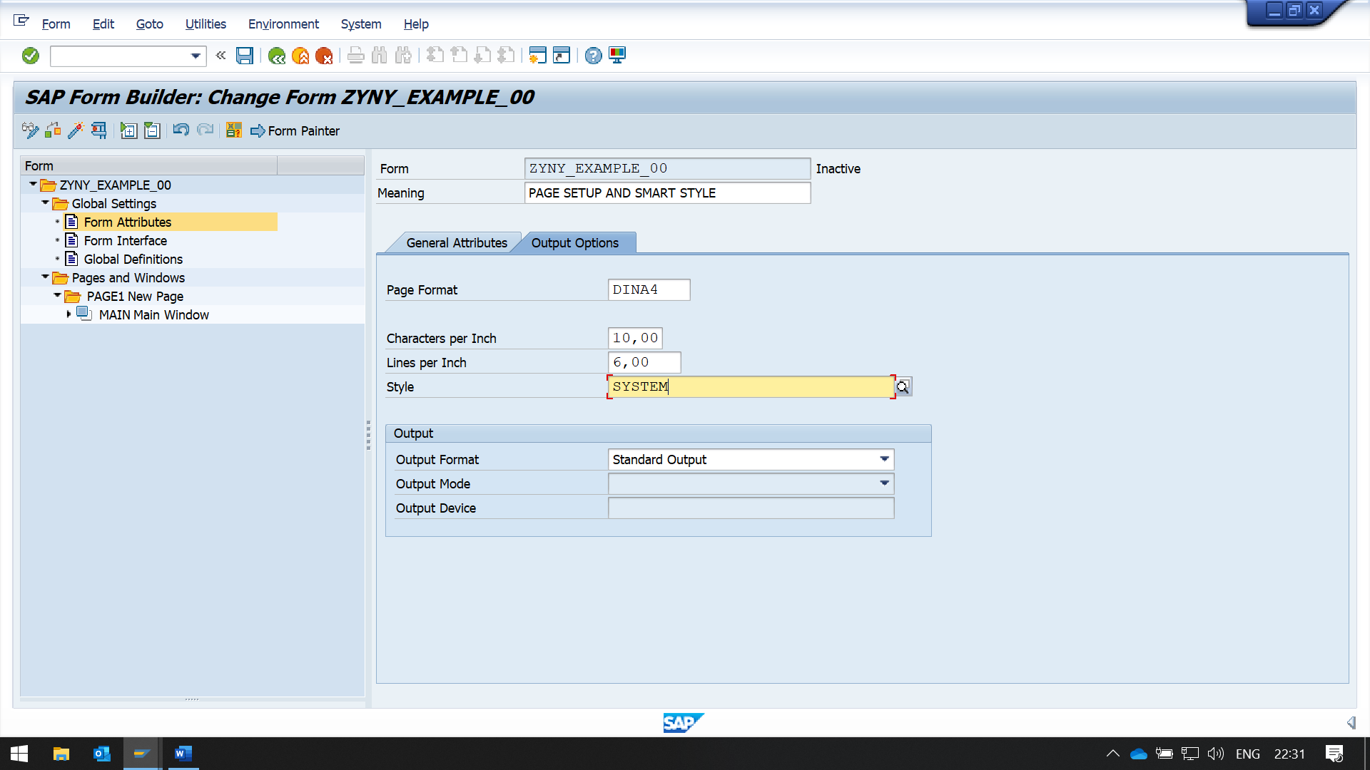

HERE WE CAN PROVIDE OUR CUSTOM STYLE FOR THE PAGE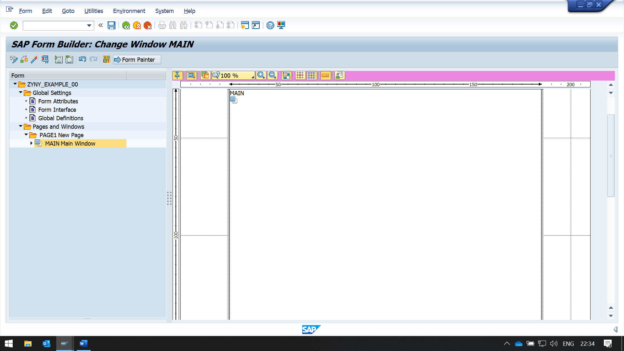

BY CLICKING ON THE FORM PAINTER, WE CAN SET THE MARGIN LENGTH HERE DIRECTLY

NOW CREATING STYLE FOR STYLE DEMO

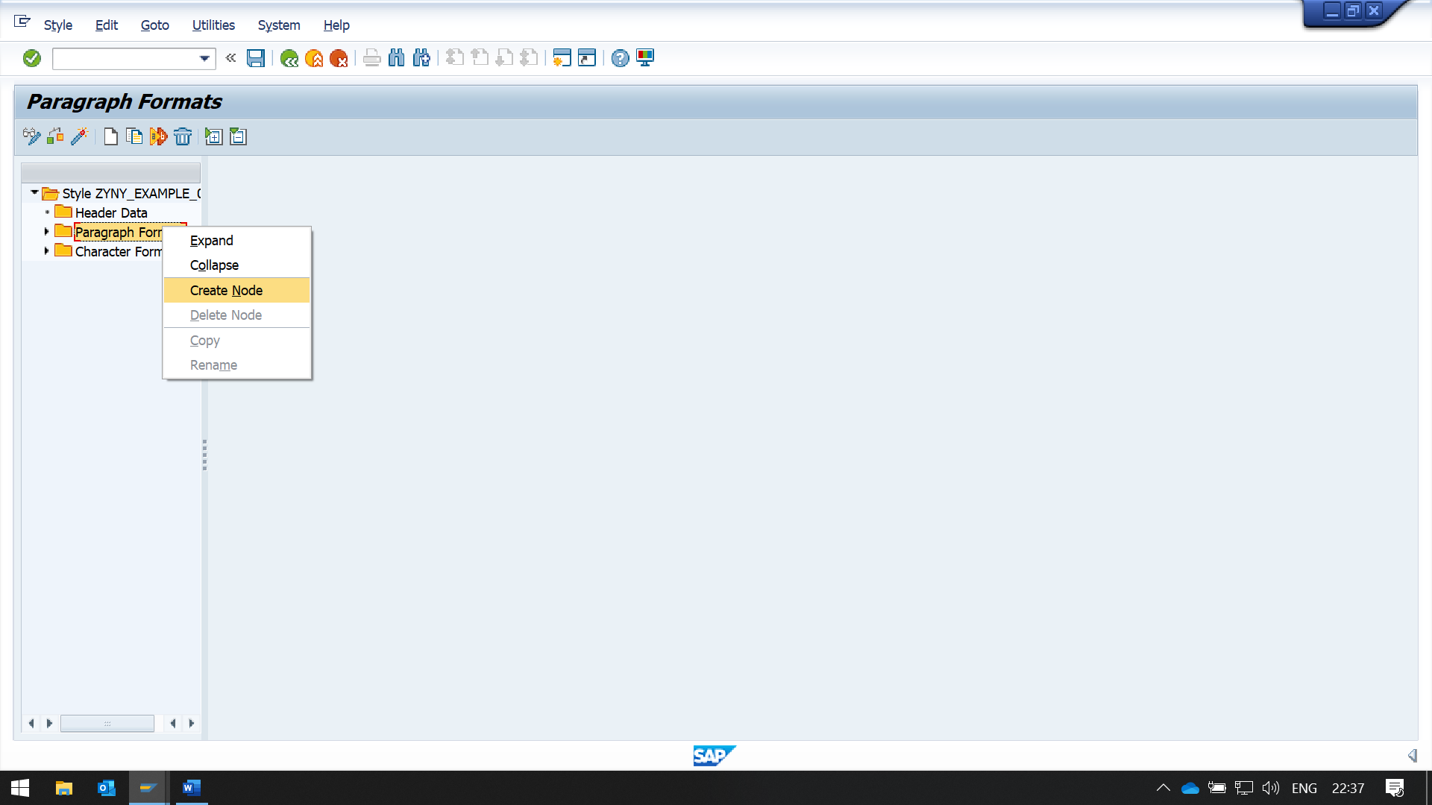

FOR PARAGRAPH STYLING, CREATE A NEW NODE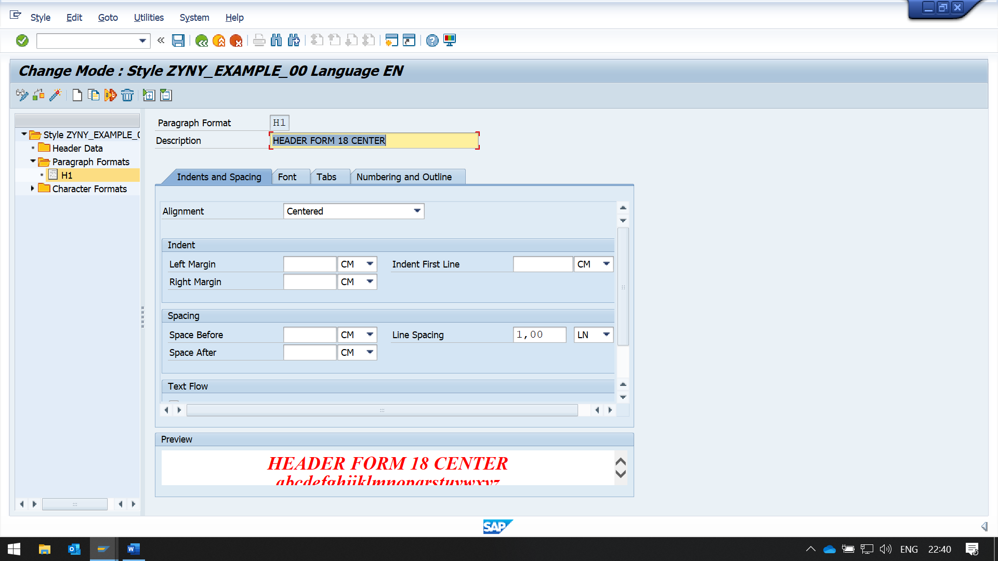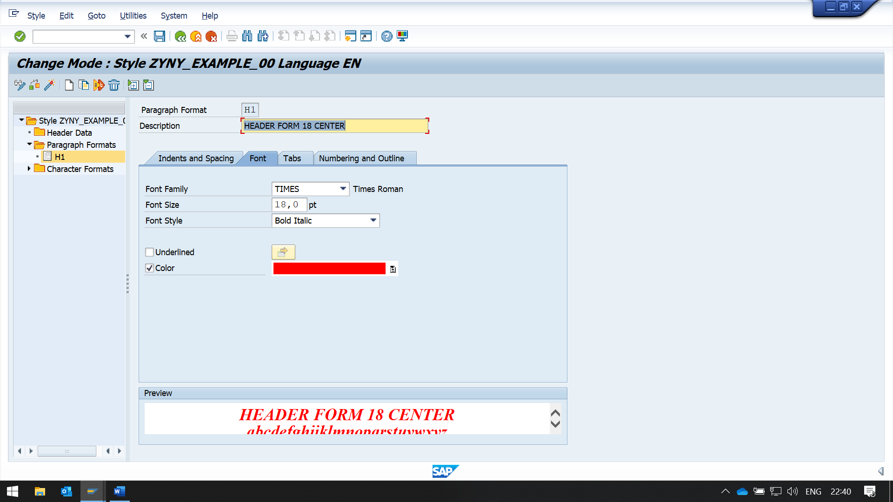HERE IN THE STYLING, WE CAN CHANGE THE ALIGNMENT , FONT, SIZE, STYLE AND COLOR OF THE TEXT.

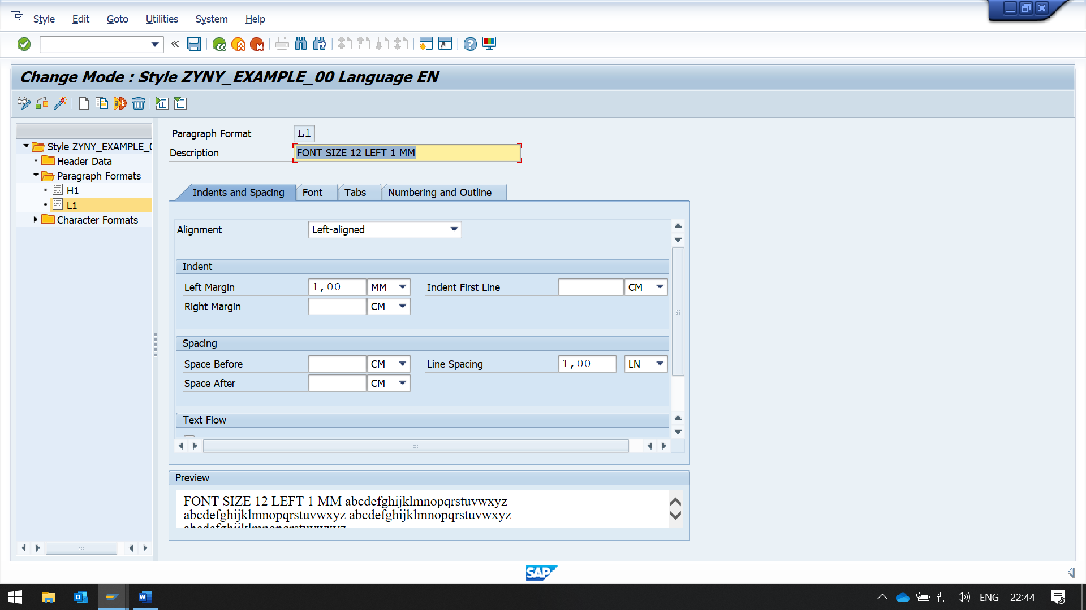

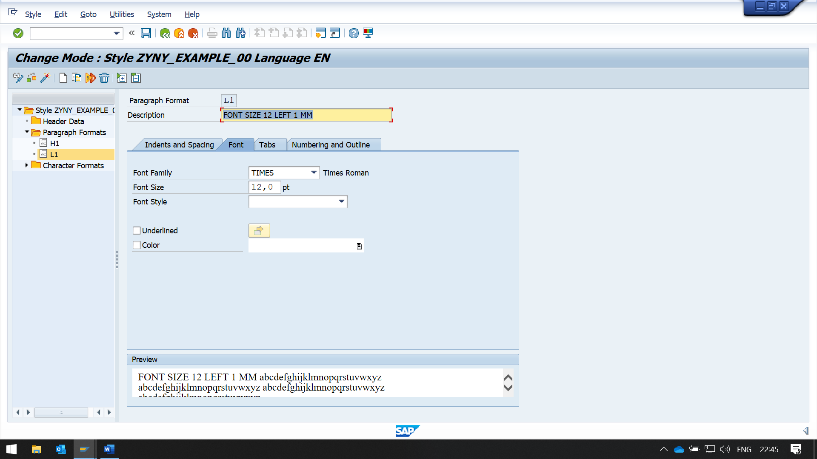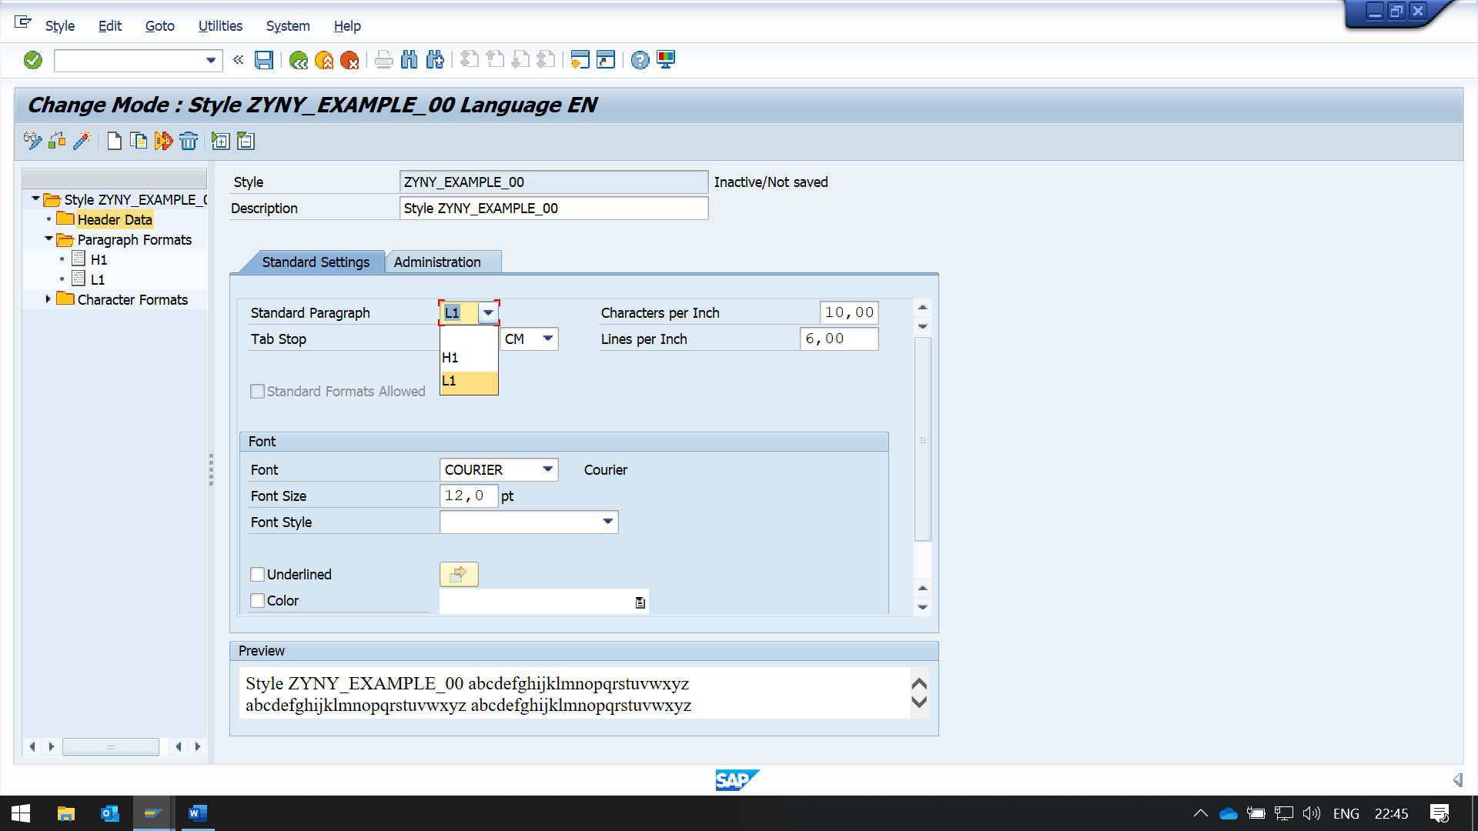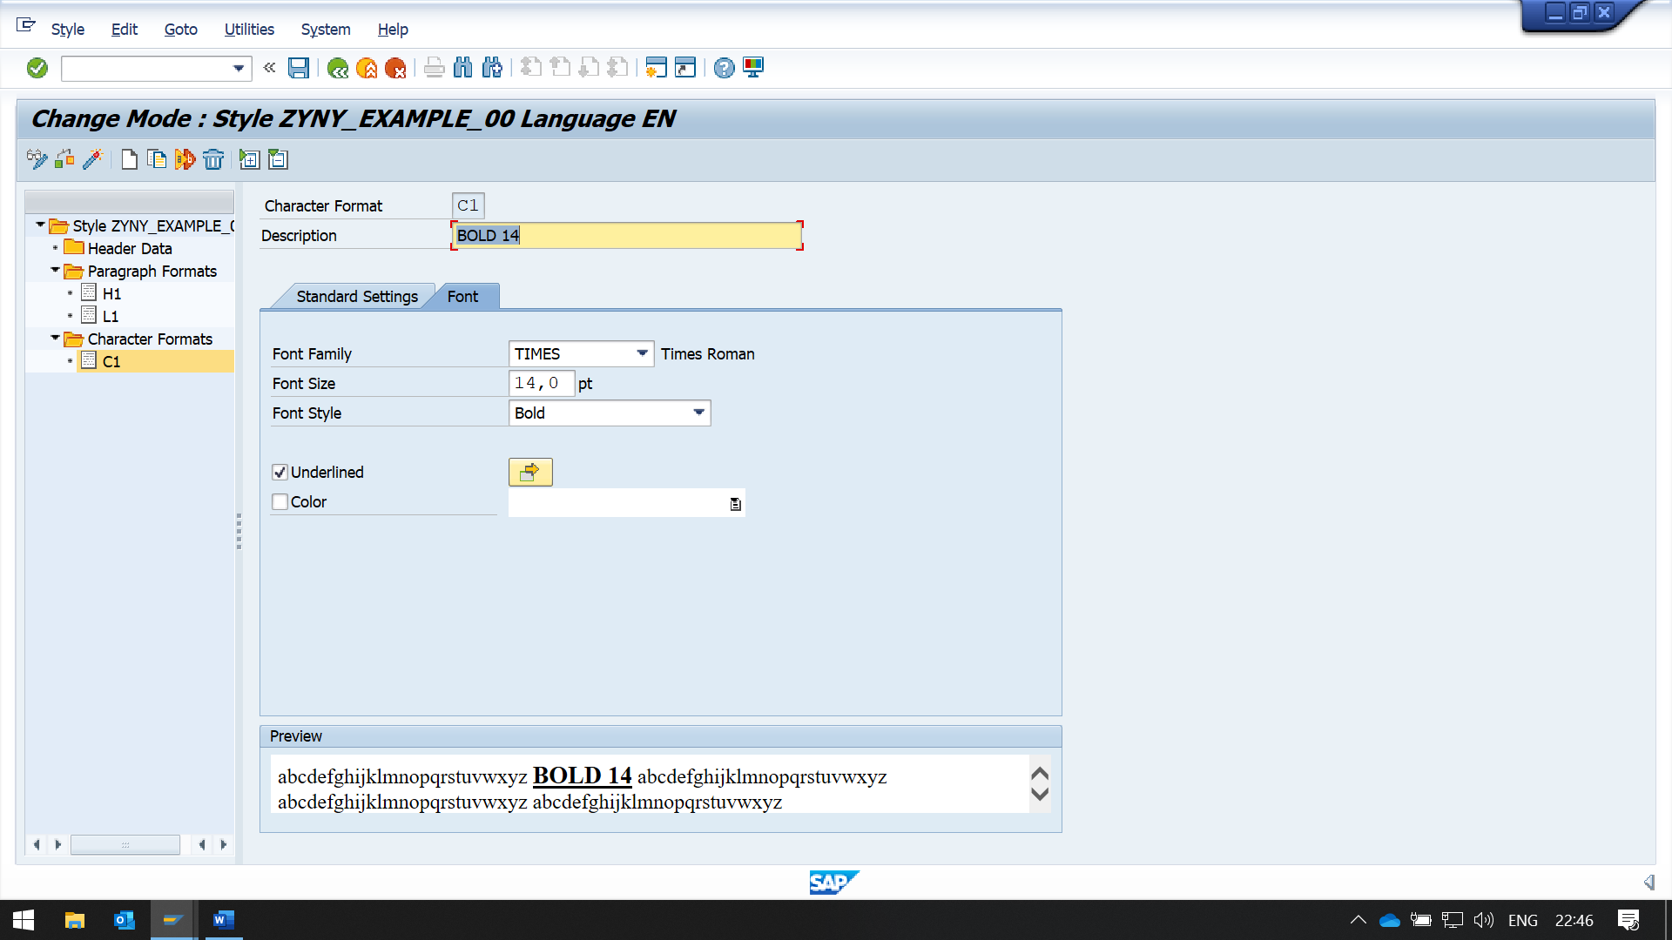

SAVE AND ACTIVATE

NOW TO USE THIS STYLE IN THE FORM

GO THE SMARTFORM -> FORM ATTRIBUTES

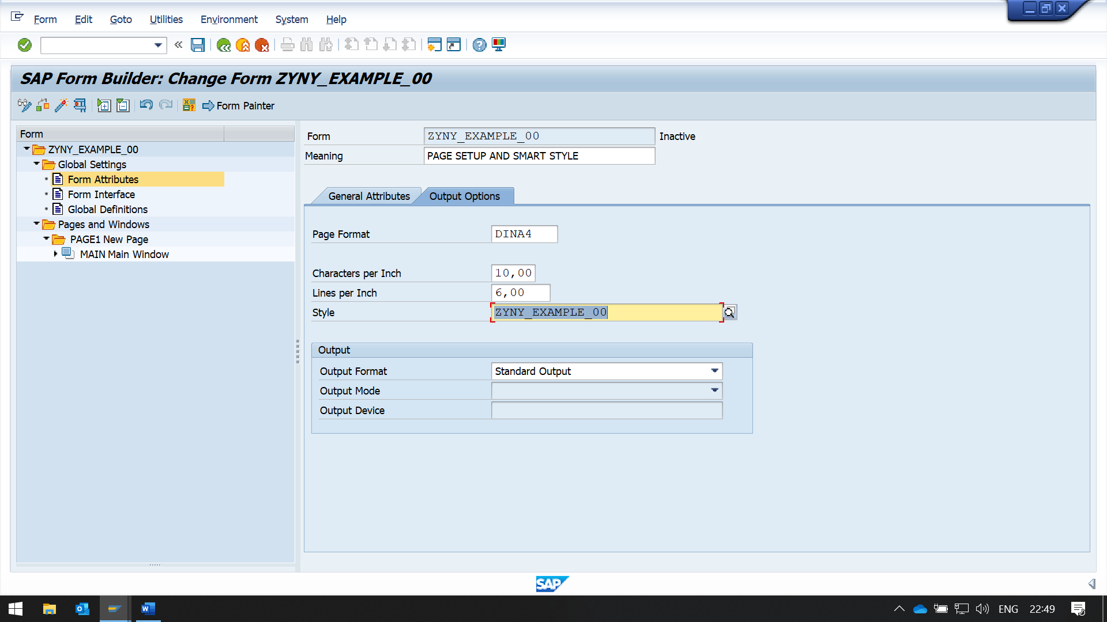

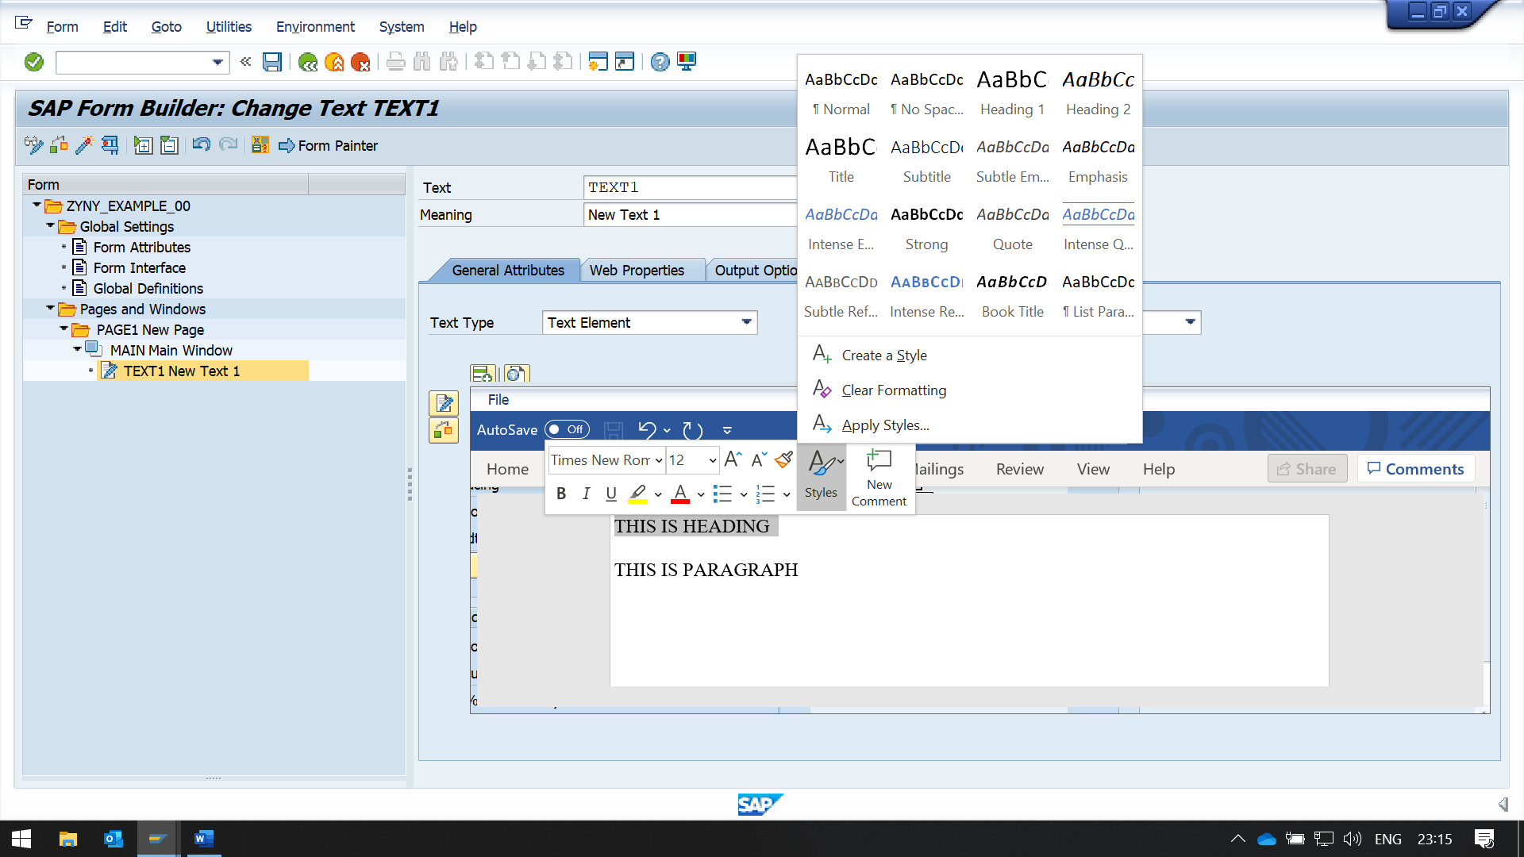NOW CLICK ON APPLY STYLES

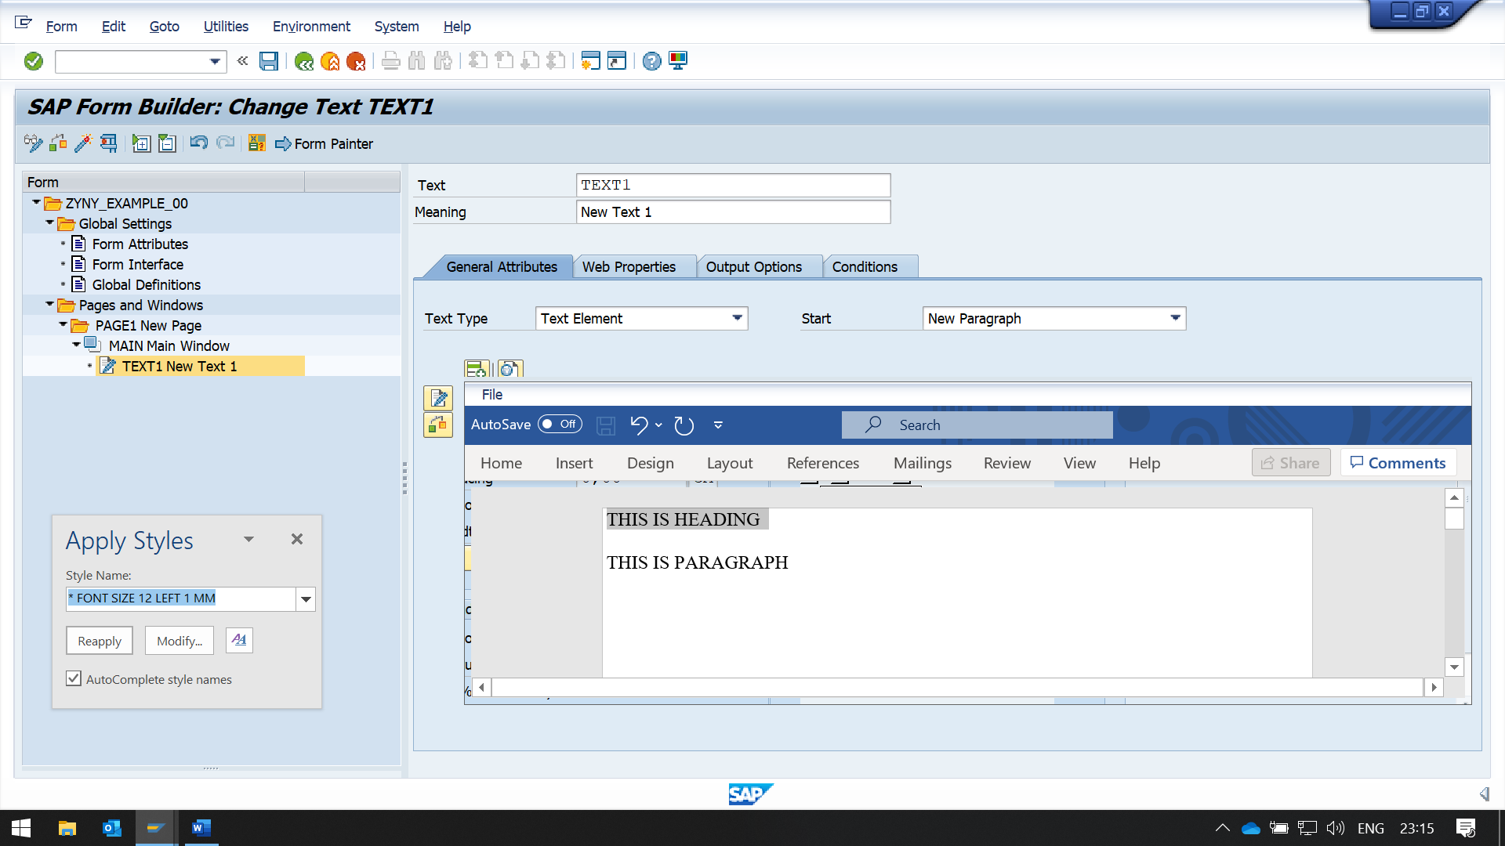CHOOSE THE STYLE FROM THE LIST

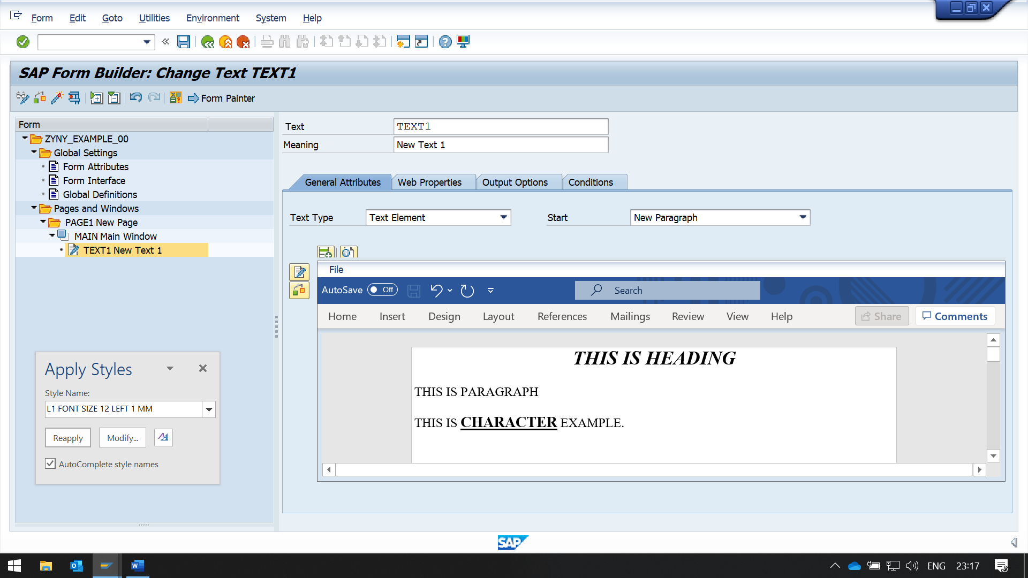

DEMO FOR DYNAMIC TEXT

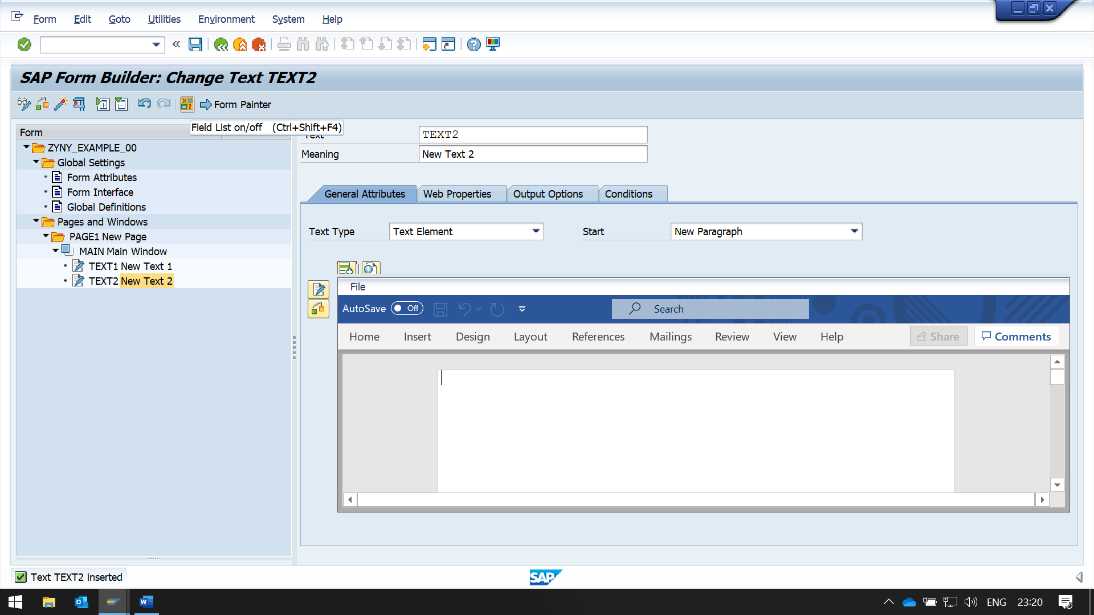NOW CLICK ON THE FIELD LIST WHICH IS BELOW TOOL BAR

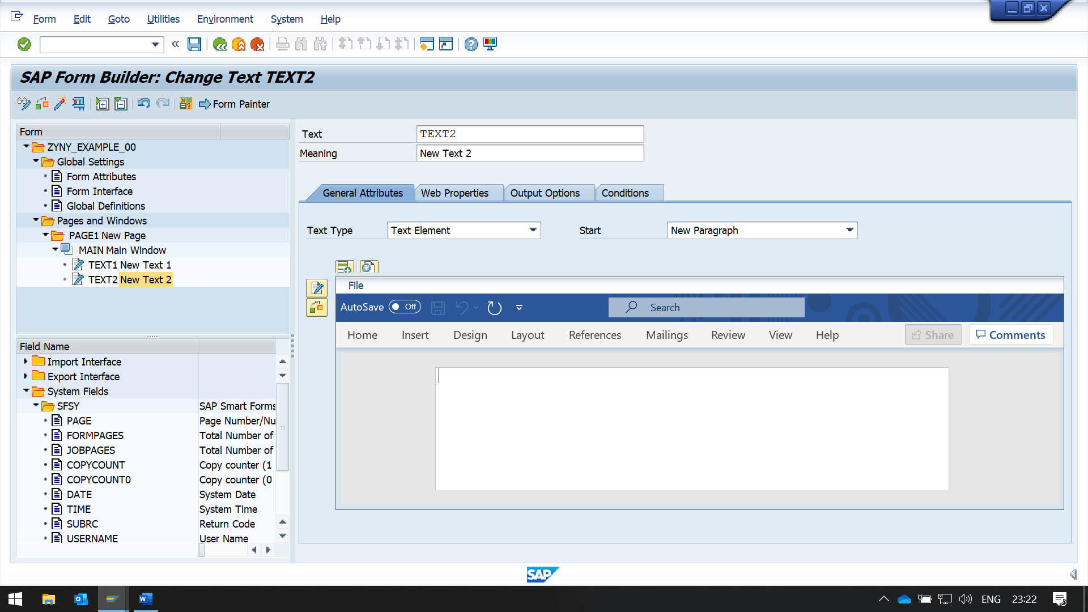

NOW FROM SYSTEM FIELDS DRAG AND DROP DATE AND TIME TO THE EDITOR

BUT IT'S NOT WORKING IN THIS SAP VERSION

